Our Ref: _______________ Your Ref: ________________________ Date: __________________

Baptist Church

Baale Yaku Site Area, P. O. Box 644,

Ogbomoso, Oyo State. Tel. 07052425407

Email: [newsprinbaptistchurch@gmail.com](mailto:newsprinbaptistchurch@gmail.com)

Website: newspringbc.comze.com

NEW SPRING

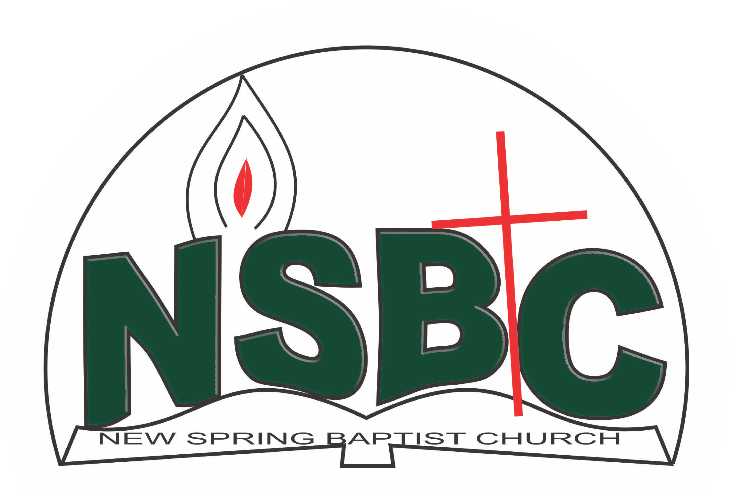

2 January 2022

Dear Mr. Segun Adetutu,

Nomination to Serve as an Officer and Worker in the Church in 2022.

Calvary greetings in the precious name of our Lord and Saviour Jesus Christ. It is our pleasure to inform you that at the Church-in-Conference held on December 19, 2021; the Church ratified your nomination to serve in the following areas between January 1 and December 31, 2022:

1. Church History Committee under the chairmanship of Mr. Yemi alamu
2. Media/Sound Unit under the chairmanship of Mr. Tunde Oladeji
3. Assistant Secretary/Programme Coordinator, Men’s Missionary Union (MMU)

Please refer to the table below for the key functions of each of these roles. Details can be found in the Church constitution. You are strongly encouraged to become familiar with the tasks as stated in the document. There will be an orientation of the Church workers on January 22, 2022 at 8:30 a.m. on the church premises. Please ensure you participate in this training.

“Now it is required that those who have been given a trust must prove faithful. I Corinthians 4:2”. May God find you faithful in the task He has assigned to you.

| Domain | Key function of Office, Department or Committee |
| --- | --- |
| Member, Church History Committee | The purpose of the committee is to document past and current key events in a systematic manner so that the evolution of the Church can be understood when her history is reviewed in the future. |
| Media/Sound Unit | The purpose of the sound unit is to ensure the public address system is working properly during worship services and other Church programmes where a public address system is required and the media unit shall provide technical support in the use of electronic equipment to enhance worship experience. |
| Assistant Secretary/Programme Coordinator, MMU | To divulge programmes of the MMU and assist the Secretary |

Thank you for accepting to serve in this Church.

Yours in His service,

Olusayo Okediji Blessed Agboola

Church Secretary                                                                                     Chairman, Nominating Committee

2 January 2022

Dear Mrs. Comfort Majekolagbe,

Nomination to Serve as a Worker in the Church in 2022.

Calvary greetings in the precious name of our Lord and Saviour Jesus Christ. It is our pleasure to inform you that at the Church-in-Conference held on December 19, 2021, the Church ratified your nomination to serve in this area between January 1 and December 31,2022:

1. Children’s Worker under the leadership of Pst. Paul Adeoye
2. Sunbeam Leader

Please refer to the table below for the key functions of each of these roles. Details can be found in the Church constitution. You are strongly encouraged to become familiar with the tasks as stated in the document. There will be an orientation of the Church workers on January 22, 2022 at 8:30 a.m. on the church premises. Please ensure you participate in this training.

“Now it is required that those who have been given a trust must prove faithful. I Corinthians 4:2”. May God find you faithful in the task He has assigned to you.

| Domain | Key function of Office, Department or Committee |
| --- | --- |
| Children’s Department | The committee is responsible for organizing activities that contribute to the spiritual nurture of children from birth to 12 years. |
| Sunbeam Leader | Work with the WMU President for the spiritual nurture of children |

Thank you for accepting to serve in this Church.

Yours in His service

Olusayo Okediji Blessed Agboola

Church Secretary Chairman, Nominating Committee